**Splash - White Water Rafting Site Plan**

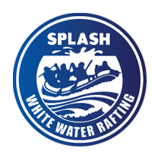

* primary-color – #1C5D99
* secondary-color – #222222
* accent1-color – #5AC4C4
* accent2-color – #E6E6E6
* heading-font – [Trade Winds](https://fonts.google.com/specimen/Trade+Winds)
* text-font – [Nunito Sans](https://fonts.google.com/specimen/Nunito+Sans)

https://coolors.co/222222-5ac4c4-e6e6e6-1c5d99